**Exercise 2: Implement a Stored Procedure**

Create a procedure called update_stock(product_id INT, quantity INT) that updates UnitsInStock in the Products table for a given product ID.

Test: Update the stock quantity for product ID 11.

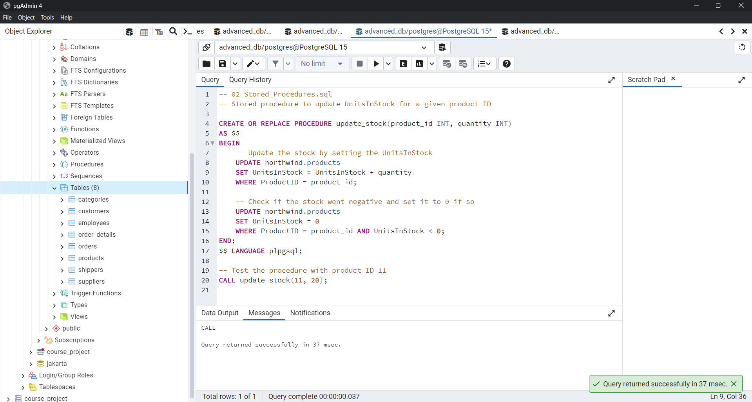

CHECK IF IT WORKS

